**React JS – HOL**  
  
**9.ES6 Features and React Hands-on Lab: Cricket Application (cricketapp)**

**React Components Overview**

**1. ListofPlayers.js**

* **Purpose:** Displays a list of 11 players along with their scores.
* **ES6 Features Used:**
  + map() to iterate through player objects
  + Props to pass data

{players.map((player, index) => (

<li key={index}>Mr. {player.name} {player.score}</li>

))}

**2. Scorebelow70.js**

* **Purpose:** Filters and displays players with a score below 70.
* **ES6 Features Used:**
  + Arrow function in filter()

js

const below70 = players.filter(player => player.score < 70);

**3. IndianPlayers.js**

* **Purpose:**
  + Declares two arrays: T20players and RanjiTrophyPlayers
  + Merges them using spread operator (...)
  + Uses array destructuring to separate first, second, and remaining players.
* **ES6 Features Used:**
  + Spread operator for merging
  + Array destructuring

const allPlayers = [...T20players, ...RanjiTrophyPlayers];

const [first, second, ...rest] = allPlayers;

**4. OddPlayers.js & EvenPlayers.js**

* **Purpose:** Displays players at odd and even indices.
* **ES6 Features Used:**
  + Destructuring in component props
  + filter() and map() for selective rendering

{IndianTeam.filter((_, index) => index % 2 === 0).map(...)}

**5. ListofIndianPlayers.js**

* **Purpose:** Displays list of Indian Players passed via props.
* **ES6 Features Used:**
  + map() for rendering lists

js

Copy code

{IndianPlayers.map((player, index) => (

<li key={index}>Mr. {player}</li>

))}

OUTPUT

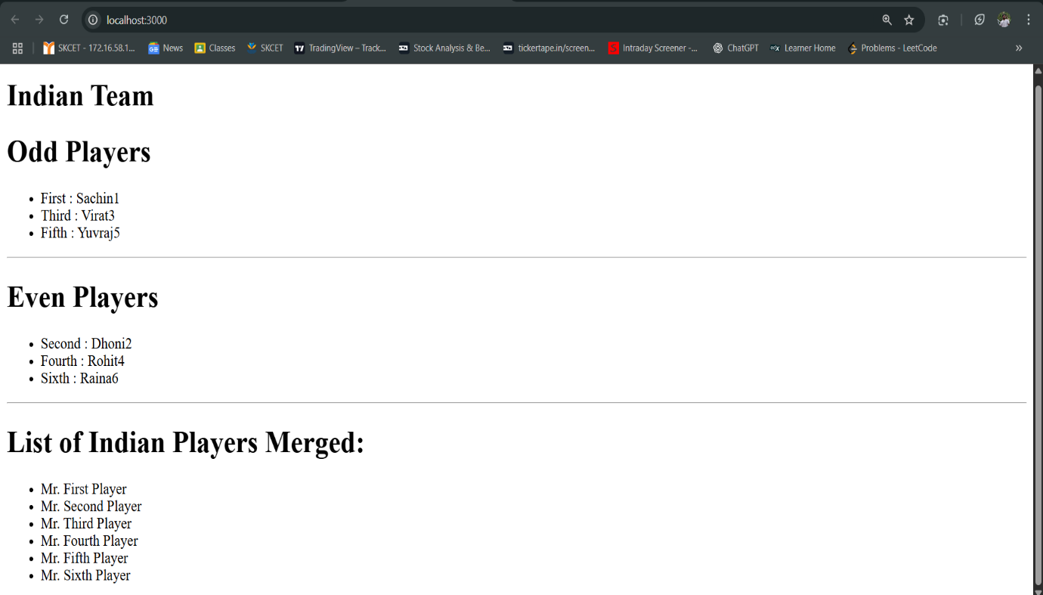

10

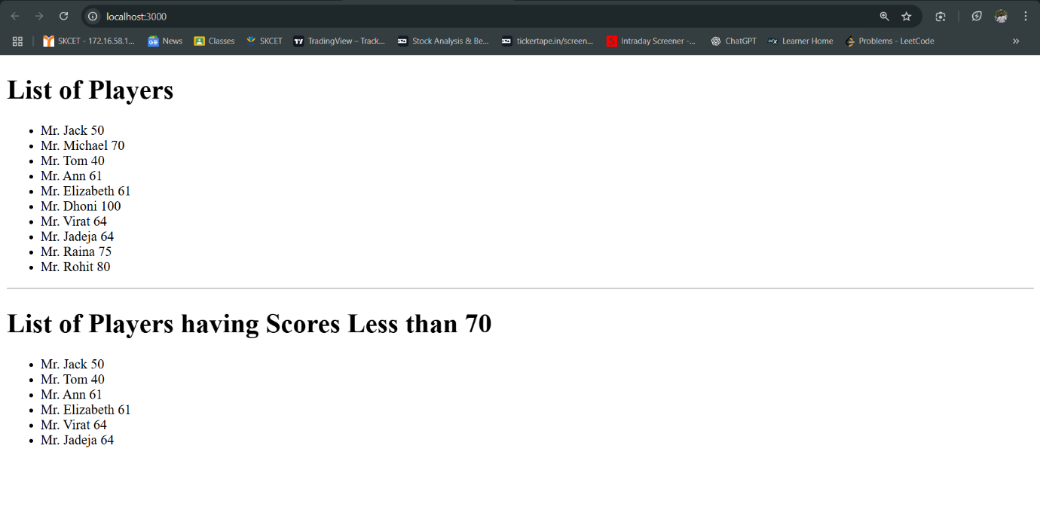

**10.React JS – HOL**

->Created an element to display the heading of the page.

->Attribute to display the image of the office space

->Created an object of office to display the details like Name, Rent and Address.

->Created a list of Object and loop through the office space item to display more data.

->Applied Css, Display the color of the Rent in Red if it’s below 60000 and in Green if it’s above 60000.

**OUTPUT**

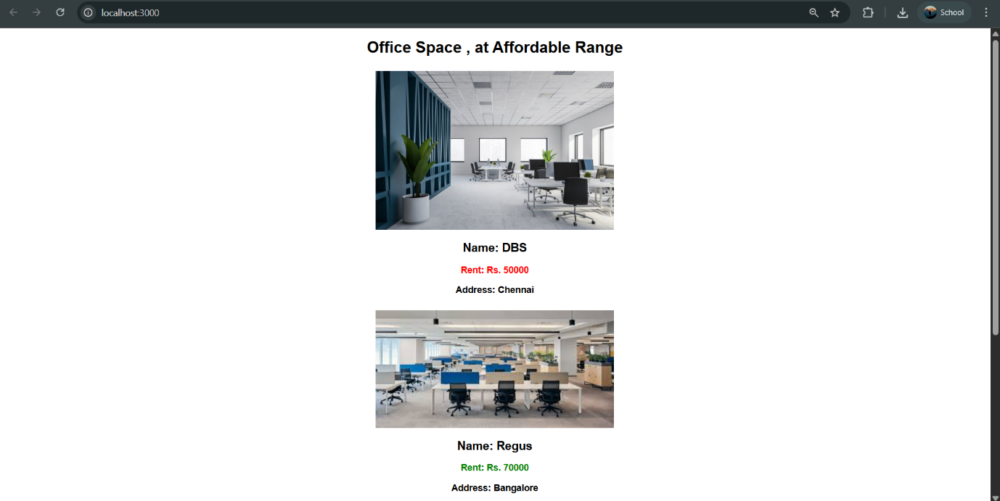

**11 React JS – HOL**

Created a React Application “eventexamplesapp” to handle various events of the form elements in HTML.

1. Created “Increment” button to increase the value of the counter and “Decrement” button to decrease the value of the counter. The “Increase” button should invoke multiple methods.

a. Incremented the value

b. Said Hello followed by a static message.

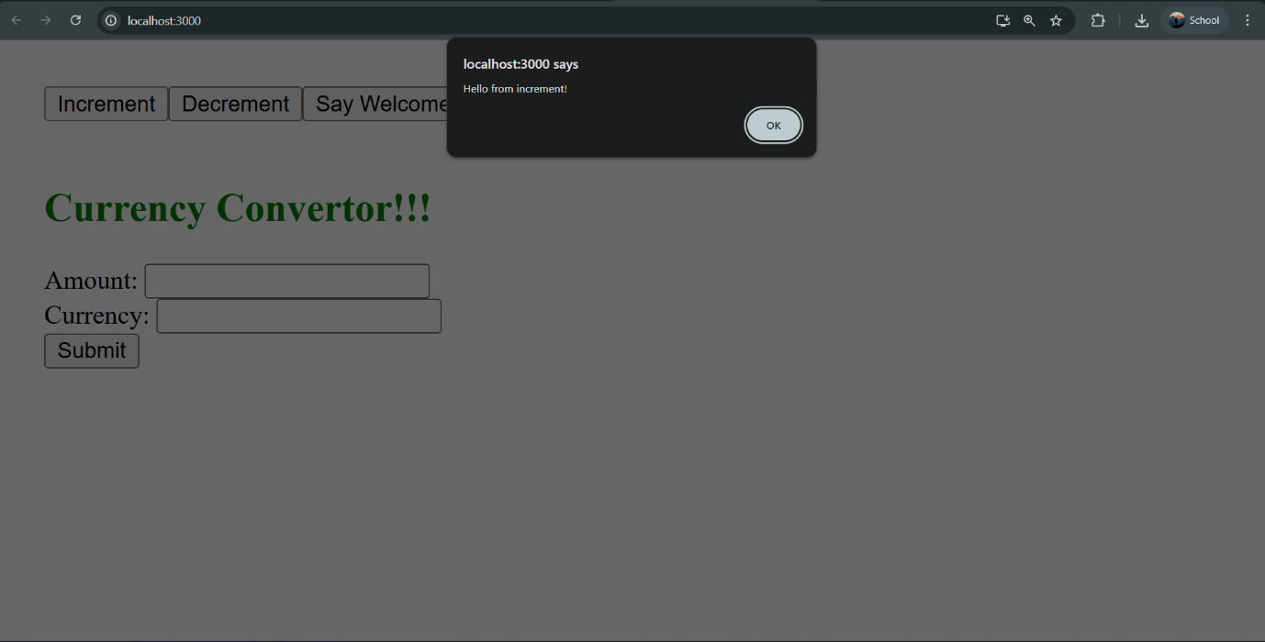

2. Created a button “Say Welcome” which invokes the function which takes “welcome” as an argument.

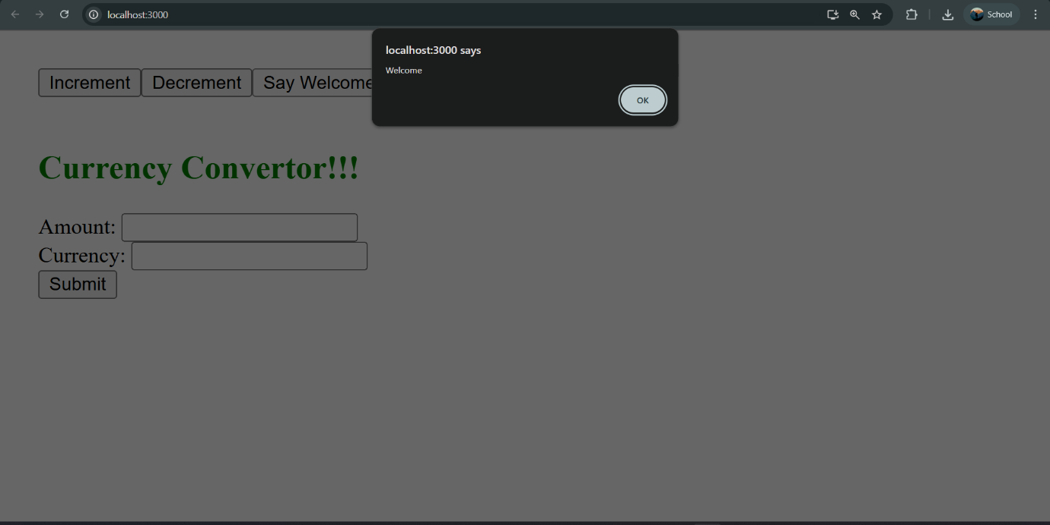

3 Created a button which invokes synthetic event “OnPress” which display “I was clicked”

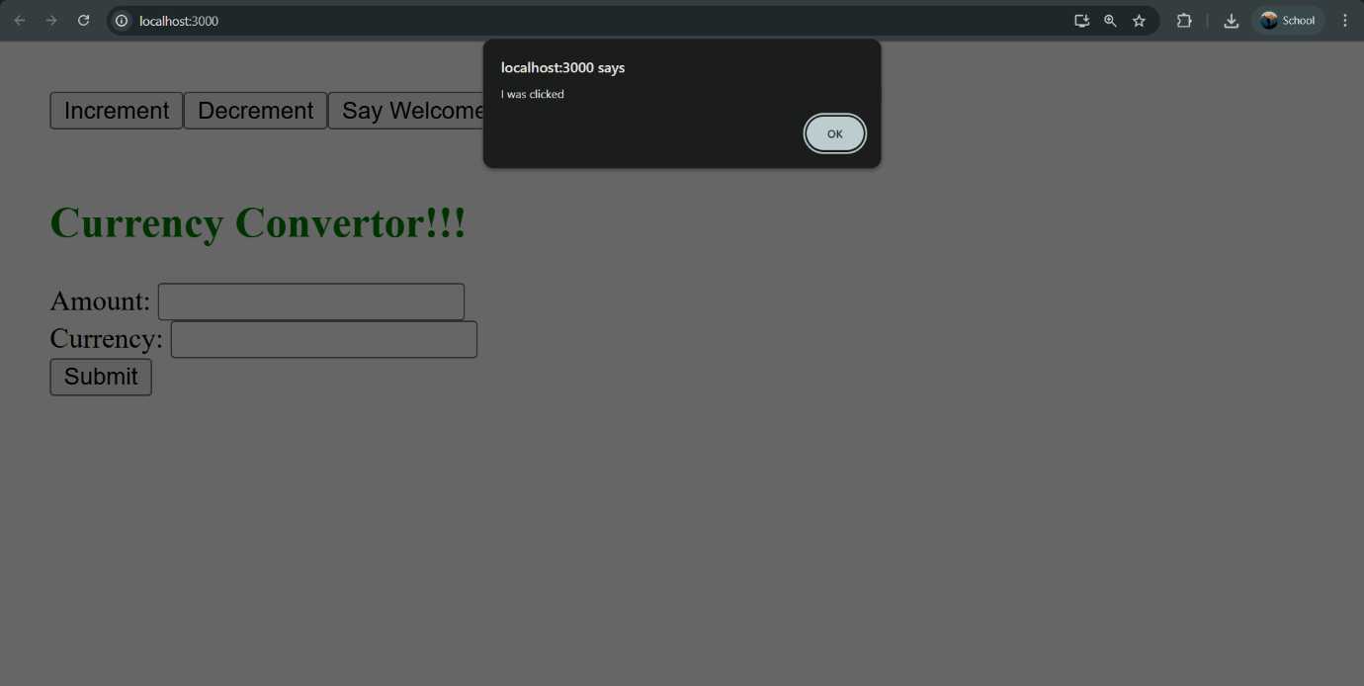

Created a “CurrencyConvertor” component which will convert the Indian Rupees to Euro when the Convert button is clicked.

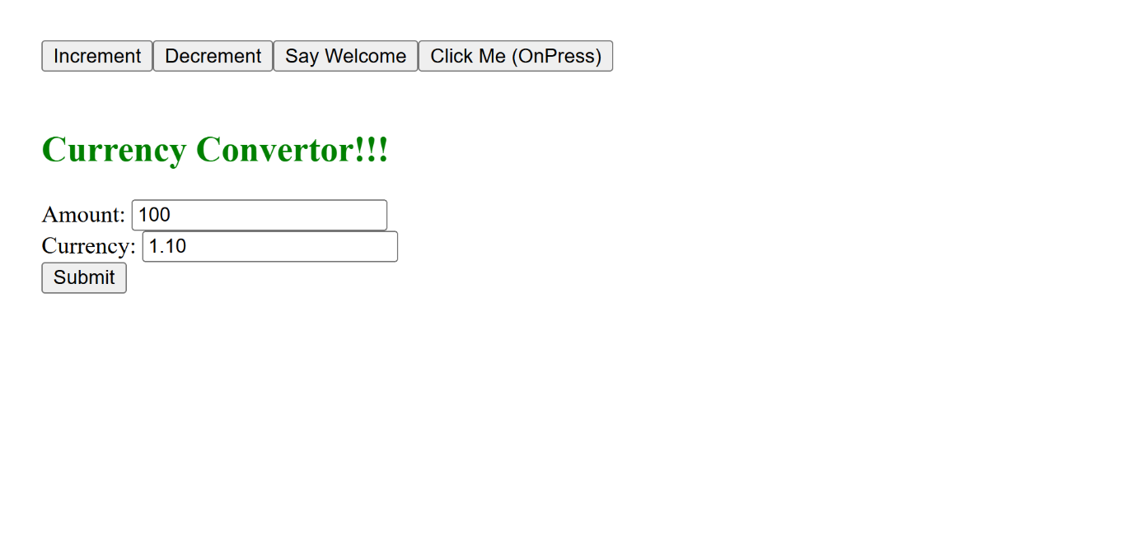

**12 React JS – HOL**

Created a React Application named “ticketbookingapp” where the guest user can browse the page where the flight details are displayed whereas the logged in user only can book tickets.

The Login and Logout buttons should accordingly display different pages. Once the user is logged in the User page should be displayed. When the user clicks on Logout, the Guest page should be displayed

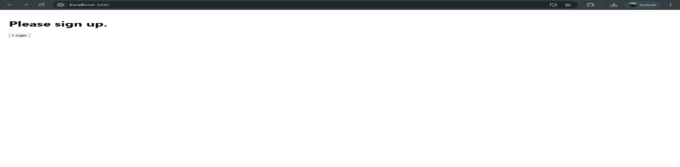

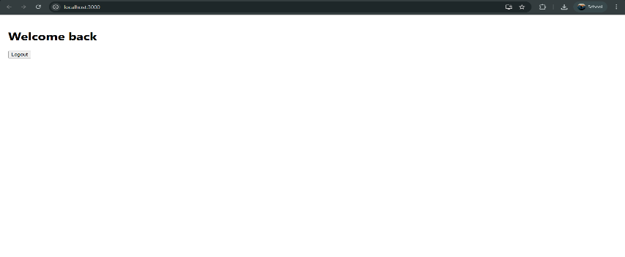

**13 React JS – HOL**

Createda React App named “bloggerapp” in with 3 components.

1. Book Details

2. Blog Details

3. Course Details

Implemented this with as many ways possible of Conditional Rendering

OUTPUT

